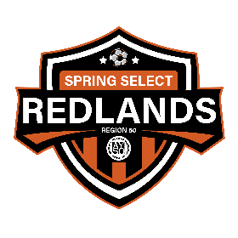
Redlands AYSO Spring Select 20XX

Dear Friends,

The Redlands American Youth Soccer Organization Spring Select teams are currently preparing for the 20XX season. Our team is composed of young ladies/men between the ages of XX and XX. Each player was selected for her/his soccer skills, family participation, and her/his ability to represent her/his community.

The Spring Select season runs from January thru June and includes home games, away games, and various tournaments. AYSO is a family program with parents and friends volunteering many hours as coaches, team managers, referees etc. This enables us to favorably impact our youth while keeping our expenses reasonable.

Tournament fees, travel, and equipment are the responsibility of each team. To help defray some of these
costs our team is seeking supporters. If you can assist and are interested, please fill out the bottom of this
form and return it along with your contribution.

Any level of support you can offer is truly appreciated. The young ladies/men of the Redlands Spring Select team look forward to a terrific season.

Thank you,
XXXXXXX
Spring Select (Team info) Coach

************************************************************************************************************************

Thank you for contributing to AYSO Spring Select Soccer.
An Appreciation plaque with team photo will be given to each sponsor.

Player’s Name: _____________________________________________________________

Name of Sponsor: __________________________________________________________

Contact Person: ____________________________________________________________

Phone: ____________________________________________________________________

Please make checks payable to Redlands AYSO
Memo-Team XXXX Coach: XXXX

Redlands AYSO Sponsorship, P.O. Box 8487, Redlands, CA 92375
Tax ID # 95-6205398

